**EXPERIMENT NO. 2**

Data Filtering: Filter rows or columns based on specified criteria, such as removing outliers or selecting data within a certain range.

**1. Filtering Rows Based on a Condition**

Let's filter rows where the score is greater than or equal to 80.

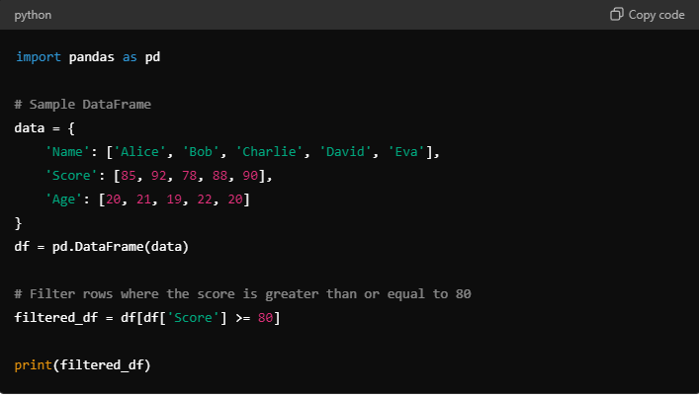

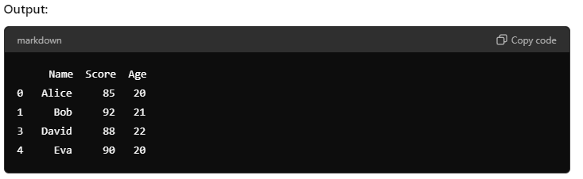

### 2. Removing Outliers

Now, we'll remove outliers by keeping only scores within a specific range (e.g., 70 to 100).

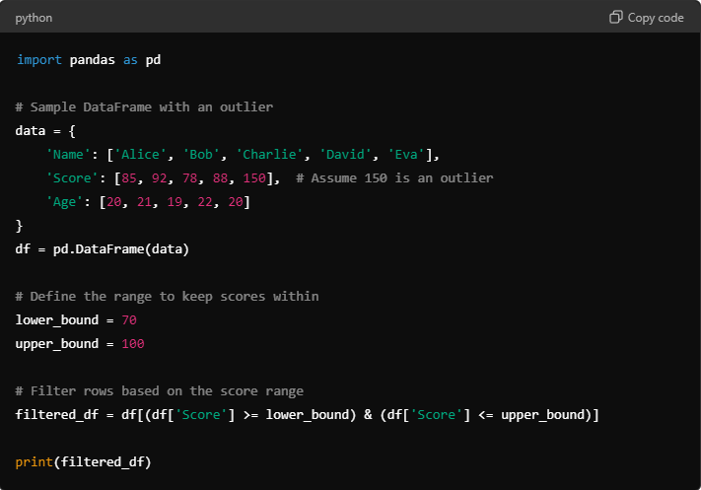

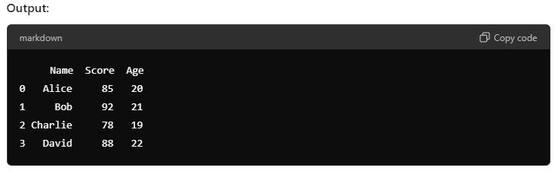

### 3. Selecting Specific Columns

Finally, let's select only the 'Name' and 'Score' columns.

